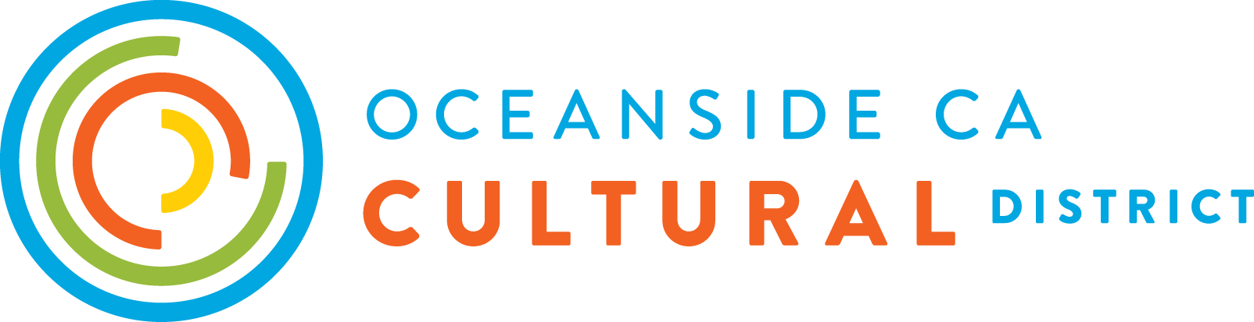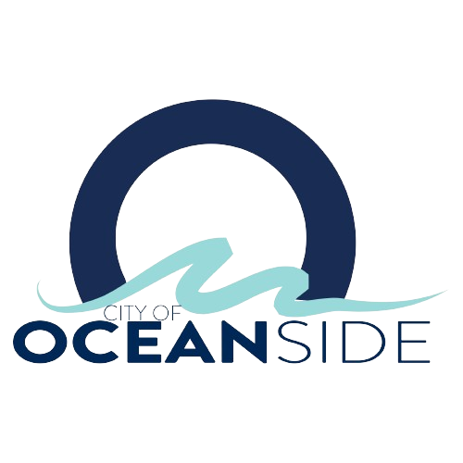

**Oceanside Arts & Culture Grant Program**

**2024 Grant Guidelines**

**Deadline: April 1, 2024**

This project is funded by Oceanside Arts Commission funds and Oceanside California Cultural District California Arts Council grant funding

**Grant Program Overview**

**2024 Grant Application Deadline: April 1, 2024 5:00 PM**

**Grant Award Amounts: $1,000, $2,500, $5,000 or $10,000**

**Total Granting Budget: $100,000**

**Background & Purpose**

The Oceanside California Cultural District has received funding from the California Arts Council (CAC) through the California Cultural District grant program. This financial support aims to foster the growth of arts and cultural activities within the district. In accordance with the Oceanside Arts Commission O'Arts Master Plan (Goal 1, Strategy 3; Goal 3, Strategy 2), the City of Oceanside Arts Commission has contributed matching funds, enabling the distribution of grants to local artists, cultural practitioners, and arts and culture organizations for the development of arts and culture programs throughout the city.

The Oceanside Arts & Culture Grant Program funds arts and culture programs occurring throughout the City of Oceanside. The total allocation for this grant program is $100,000, with grants available in amounts of $1,000, $2,500, $5,000 or $10,000. All complete applications will undergo evaluation through a fair and impartial panel process. If you are interested in serving as a panelist, please visit [www.oceansidelibrary.org/about-us/oceanside-cultural-district](https://www.oceansidelibrary.org/about-us/oceanside-cultural-district) for more information.

**Eligibility**

Eligible **individual artist** applicants will meet the following criteria:

* At least 18 years of age on the date of application submission
* Ability to demonstrate history of past creative projects or programming

Eligible **organizations** will meet the following criteria:

* 501(c)(3) non-profit organization as applicant
* An applicant organization without non-profit status must use a California-based fiscal sponsor with a federal 501(c)(3) designation to apply for funding.
* Ability to demonstrate history of past creative projects or programming
* All nonprofit organizations and fiscal sponsors must be registered vendors with the City of Oceanside at the time of award distribution.

Artists and organizations from outside the City of Oceanside are encouraged to apply. However, funding priority will be given to applicants who are currently residing in the City of Oceanside. Applications that are incomplete or submitted after the grant application deadline will not be accepted. Late submissions will not be considered as eligible.

**Application Requirements**

Eligible submissions will include the following:

* Completed application form
* 5-10 Work Samples
* Proposed Program Budget
* Resume/CV (individual artists) or Mission Statement (organizations)

**Program Requirements**

The Oceanside Arts & Culture Grant funds arts and culture programs occurring throughout the City of Oceanside. Eligible programs must take place in the City of Oceanside, California during the grant period. All grantees must complete and submit a brief final report to determine that program goals have been met within the program timeline.

**Funding Restrictions**

Ineligible applicants and organizations include:

* For-profit organizations without fiscal sponsorship
* Government agencies or entities

Grant funding can not be used for:

* Programs taking place outside of the City of Oceanside
* Programs completed prior to the grant period
* Reimbursement for purchases made prior to the grant period
* Programs that discriminate against participants based on race, gender, religion, or other protected characteristics
* Lobbying or political activities
* Operating expenses unrelated to the proposed program
* Fundraising events or activities
* Programs that violate local, state or federal laws
* Programs lacking appropriate permits or approvals for completion

**Online Application Portal**

Applications must include all requested items at the time of submission in order to be considered for funding. Applications must be submitted online by April 1, 2024 at 5pm. Applicants are encouraged to fully review program guidelines before beginning

the application process. Submit your grant application online [www.oceansidelibrary.org/about-us/oceanside-cultural-district](https://www.oceansidelibrary.org/about-us/oceanside-cultural-district)

It is recommended that applicants attend the grant workshop provided virtually on **Thursday, March 8, 2024 at 12pm**. Information regarding the scoring rubric utilized by panelists, program guidelines, and the online application will be addressed. The informational workshop will be hosted via [Zoom](https://us02web.zoom.us/j/87570683279?pwd=RHk4djI0T2JHQUJFZzJWUXdrb2R6Zz09). The online workshop will be recorded and posted to the Oceanside Public Library's YouTube channel for viewing.

For assistance, additional guidance, or access accommodations to complete the online application or view the workshop, please reach out to Cultural District staff at culturaldistrict@oceansideca.org.

**Panel Scoring Process**

A qualified review panel will score complete and eligible applications for the selection of grant awardees. Applications will be evaluated by a panel of recognized field representatives who will rank applications according to a comprehensive scoring rubric. The panel scoring rubric is available for viewing on our website.

**Program Timeline**

March 1, 2024 Grant Application Opens

March 8, 2024 Virtual Application Workshop

**April 1, 2024 Grant Application Deadline**

April 19, 2024 Panel Deliberation

April 26, 2024 Award Notification

June 2024 Award Distribution

July 2024 - May 2025 2024-25 Grant Funding Period

June 2025 Final Report Due

Oceanside CA Cultural District reserves the right to modify the dates and timelines listed at its sole discretion.

**QUESTIONS?**

If you have questions or require staff assistance for program guidance, clarification or access accommodations, please contact Cultural District staff at [culturaldistrict@oceansideca.org](mailto:culturaldistrict@oceansideca.org). Please note that staff assistance may not be available after 5pm.